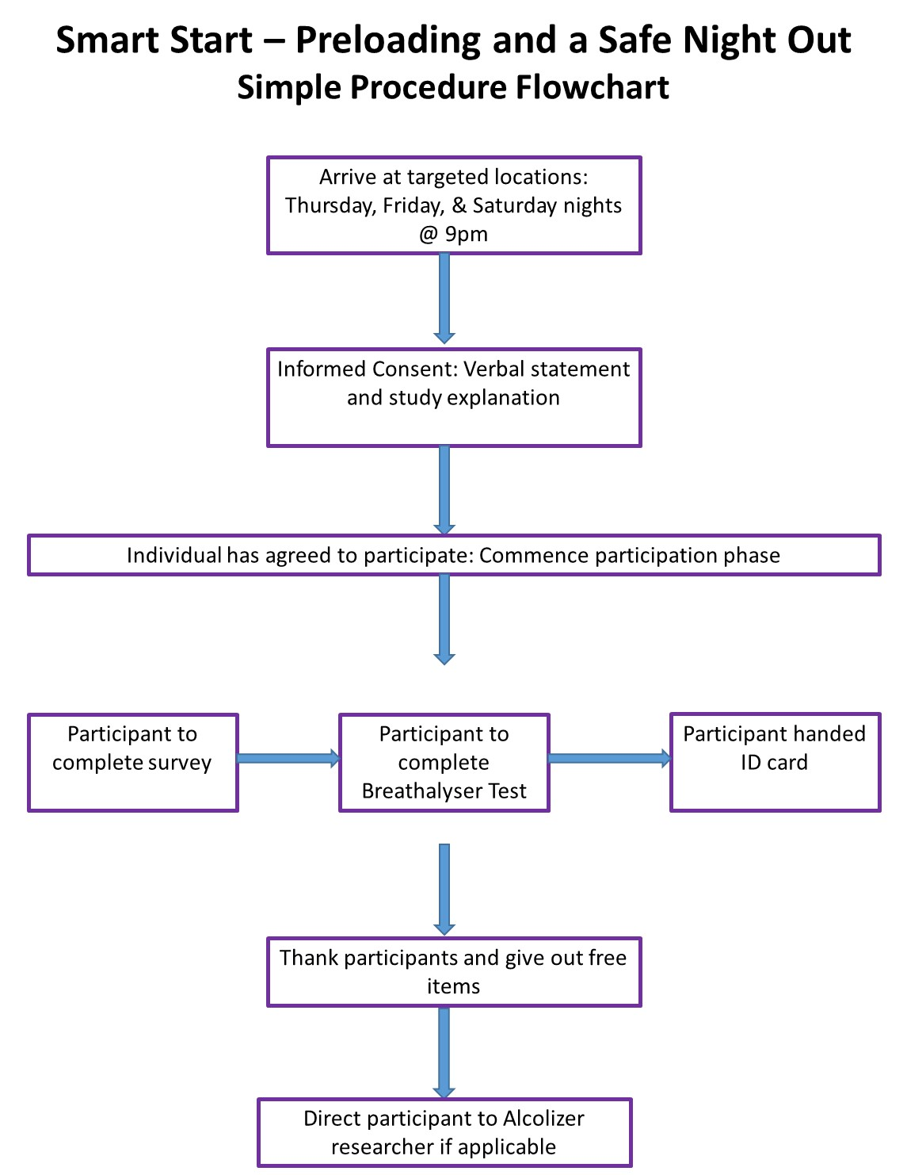

*Note*: Alcolizer Researcher = drug tester (one of our research assistants – not from a separate company, Alcolizer, who is providing the drug testing equipment).